Software Requirements Specification

for

Online Handicraft Shopping App

Version 1.0 approved

Prepared by

Avinash Chovatiya

Krishna Antala

Sahil Gajera

Hetvi Vadalia

RK University

09/09/2022

**TABLE OF CONTENT**

**Revision History**

**Chapter 1: Introduction**

1. Purpose
2. Document Convention
3. Intended Audience
4. Project Scope
5. Reference

**Chapter 2: Overall Description**

2.1 Product Perspective

2.2 Product Feature

2.3 User Characteristics

2.4 Operating environment

2.5. General Constrains

2.6 User Documentation

2.7 Assumption and Dependencies

**Chapter 3: System Features**

3.1 Register and Login

3.2 Add to Cart and View Cart

3.3 Confirm Order

3.4 Add and Update Products

3.5 View Order Details

**Chapter 4: External Interface requirements**

4.1 User Interface

4.2 Software Interface

4.3 Hardware Interface

4.4 Communication interface

4.5 Functional Requirement

**Chapter 5: Other Nonfunctional Requirements**

5.1 Performance Requirements

5.2 Safety Requirements

5.3 Security Requirements\

5.4 Software Quality Attributes

**Appendix A**: Glossary

**Appendix B:** Analysis Models

**Appendix C**: Future Enhancements

Revision History

|  |  |  |  |
| --- | --- | --- | --- |
| **Name** | **Date** | **Reason For Changes** | **Version** |
| Sahil Gajera | 09/09/22 | This is the first version of this document | 1.0.0 |
| Avinash Chovatiya | 09/09/22 | This is the first version of this document | 1.0.1 |
| Hetvi Vadalia | 10/09/22 | Reviewing document | 1.0.1 |
| Krishna Antala | 10/09/22 | Reviewing document | 1.0.2 |
| Avinash Chovatiya | 11/09/22 | Adding content | 2.0.0 |
| Sahil Gajera | 12/09/22 | Adding content | 2.1.0 |
| Hetvi Vadalia | 12/09/22 | Reviewing document | 2.1.1 |
| Krishna Antala | 13/09/22 | Adding content | 2.2.0 |
| Avinash Chovatiya | 13/09/22 | Reviewing document | 2.2.1 |
| Hetvi Vadalia | 14/09/22 | Adding diagram | 3.0.0 |
| Avinash Chovatiya | 14/09/22 | Adding diagram | 3.1.0 |
| Sahil Gajera | 14/09/22 | Adding diagram | 3.2.0 |
| Krishna Antala | 14/09/22 | Reviewing document | 3.2.1 |
| Sahil Gajera | 15/09/22 | Adding content | 4.0.0 |
| Avinash Chovatiya | 15/09/22 | Reviewing document | 4.0.1 |
| Avinash Chovatiya | 18/09/22 | Adding diagram | 5.0.0 |
| Krishna Antala | 19/09/22 | Reviewing document | 5.0.1 |
| Avinash Chovatiya | 20/09/22 | Adding Frames | 6.0.0 |
| Hetvi Vadalia | 20/09/22 | Reviewing document | 6.0.1 |
| Avinash Chovatiya | 21/09/22 | Final Review | 6.1.0 |

2. **Introduction**

**1.1 Purpose**

* The Objective of this Document is to make an application in android platform for an existing Handicraft shop. Online shopping is an effective way for Consumer to buy or explore products. With Mobile application we can combines the technology with already established business and make it more feasible for customer and profitable for the owner. This documentation will make the system understandable to the reader and get them know about its working as well as the requirement for the system to build and work.

* 1. **Document Conventions**
* The Main headings in this document are of ‘Bold’ with’ Times New Roman 18pt’
* Example - 1. Introduction of format ‘1.’
* The Subsection are of ‘Bold’ with’ Times New Roman 14pt’
* Example – 1.1 purpose of format ‘1.1’
* All simple text is marked with arrow bullet in ‘Times New Roman 12pt’
* Spacing of 1 between all text

**1.3 Intended Audience and Reading Suggestions**

* This Document is also designed to be read by the developers, Project manager, Marketing staff as well as user and tester. the SRS contains the description ranging from Products function, user guide on how to use the software and its functionality and the requirement for it to work. The document is organized into 5 parts *1. Introduction*, *2. Overall Description*, *3. System Features, 4. External Interface, 5. Other Non-Functional Interface*. Read the manual based on your requirement as per given index.

**1.4 Project Scope**

* The E-Commerce Handicraft application is converting the offline shopping to online application based so that user can easily get the products from their home, and they won’t have to waste time on travelling.
* It can be used by the user for shopping as well as the seller/admin to keep tabs of the progress and their growth. It makes work easier for customer to browse through variety of product from just their home in their device.
* This will help in expanding the business with the help of current technology.

**1.5 References**

* Software Engineering: A Practitioner’s Approach Eight Edition by Roger Pressman
* <https://studylib.net/doc/25786357/srs-online-shopping>
* <https://docplayer.net/13534020-Software-requirements-specification-task-management-system-for-prepared-by-version-1-0-group-name-pink-and-purple-date.html>

1. **Overall Description**

**2.1 Product Perspective**

* This product is aimed towards the customer who can’t visit the shop, or they don’t want to travel long distance to our offline store. Handicraft galaxy is a Mobile based E-Commerce application that deals with the buying and delivering hand crafted product online and with faster delivery system it becomes very easy to shop from this application.

**2.2 Product Features**

* Quick and simple sign in using mobile number or e-mail.
* Detailed information of product on selection.
* Provided Wishlist with fast Checkout.
* Providing online service with fast response is the main Feature of this product with already established delivery system by the store so it becomes easier and faster to deliver goods, if order is made in the same region of the offline store, it will be delivered within a same day probably within few hours.

**2.3 User Classes and Characteristics**

* The intended user for this E-Commerce mobile application is the customer for as well as the admin who can access the data and do analysis based on it.
* The system will require basic understanding of how a computer works i.e., how to turn it on and all other basic technical expertise
* The user should be familiar with the shopping mall related terminology like shopping cart, checking out, transaction, etc.

**2.4 Operating Environment**

* The product will be operating in Android platform with minimum android device requirement of 4gb ram, with free space of 100mb, also android version 9 or above.
* The system will need internet access to be able to communicate with the database and surfing inside app.

**2.5 Design and Implementation Constraints**

* The system must have an internet connection, or the user will not be able to communicate with the app and to operate it throughout because of no database connectivity.
* After selecting an item and putting it into the cart afterwards at the time of checkout more information will be needed to complete the transaction such as shipping address, shipping option, payment information and otp verification for payment.

**2.6 User Documentation**

* Should there be a need for help, there will be a help menu that will guide the user through using the system. This document will also serve as for all help documentation that follows.

**2.7 Assumptions and Dependencies**

* We assume that system users adhere to the system’s minimum software and hardware requirements.
* The system should be user friendly so that it is easy to use for the users.
* The system should have more capacity and provide fast access to the database.
* The system should provide search facility and support quick transactions.
* This app is dependent on internet, so it always requires network connectivity.
* For fast and easy use of application it is required to fulfill device requirement.

1. **System Features**
   1. **Register and Login**
      1. Description and Priority

This feature creates an account for a new user in the system. For a user to be able to buy any item he/she must have an account and must be logged into it. This feature enlists the user details in the database. It has the highest priority.

* + 1. Stimulus/Response Sequences

Customer first clicks on the button or link to initiate registration process. The system then prompts the customer enter Mobile number or with Google to login. System validates the customer's information and creates a new account for the Customer. Once a customer register, he/she clicks on the log in button to initiate the login process. After otp verification the system displays account home page to the Customer.

* + 1. Functional Requirements

REQ-1: A button for register and log in must be available

REQ-2: A data in the data base must be stored for all users.

* 1. **Add to Cart and View Cart**

This feature enables for a user to browse through different products in the homepage and add any product to the cart. The user can also specify the quantity he/she wants to add to the cart. On ‘View Cart’ the user must be able to see all the items in his/her cart.

If enough quantity is not available, then a message informing the same must be displayed else the item is added to the cart of the user.

REQ-1: A button for adding to cart.

REQ-2: A button for viewing items in cart.

REQ-3: A table in the data base must be created having all the product available and each product’s details must be present.

REQ-4: A table for items added to cart must also be available.

* 1. **Confirm Order**

This feature confirms the order placed by the customer i.e., now the customer has brought the product by making payment.

Customer clicks the button or link to initiate the confirmation process. Customer confirms the order. System stores order confirmation and order details and prints the bill.

REQ-1: A template/window dealing with the items ordered must be created.

REQ-2: The table dealing with the products must be updated i.e., the quantity of the product bought must be decreased by the quantity bought once billing is done.

REQ-3: A table dealing with all the orders by different customers must be maintained.

* 1. **Add and Update Products**

This feature is available only for the administrator. Only the administrator can add products and update details of the product in the database.

Administrator clicks the button initiate Add Product process. The system prompts the administrator to fill out product details. System validates the new product information and add it to the database. clicks the button to initiate Update Product prices. The system prompts the administrator to fill out product ID. The corresponding product details are displayed. The admin can update any value except the ID of the product. System validates the new product information and update it in the database.

REQ-1: A separate login for the administrator must be created.

REQ-2: An administrator cannot buy a product.

* 1. **View Order Details**

This feature is available only for the administrator. Only the administrator can view the order details of all users.

Administrator clicks the button to initiate View Order Table process. Details of each customer and his/her order details are printed.

REQ-1: A separate login for the administrator must be created can be web portal

REQ-2: An administrator cannot buy a product.

REQ-3: An administrator cannot change the order details table

1. **External Interface Requirements**

* 1. **User Interfaces**
* There are 2 forms of users for the suggested system.
* **Administration**

Administrations are people who add or control categories for goods and are responsible for administrating delivery men.

* **End Users/Customers**

The end customer will be the one who visits the website and order items online

* 1. **Hardware Interfaces**
* Network driver must be running properly as internet is required
* **RAM:** Minimum 4gb
* **Free space:** Minimum 100mb

For admin/seller side in web portal

* **Processor**: -Pentium I or above.
* **RAM**: - 4 GB or above.
* **HDD**: - 20 GB or above.
  1. **Software Interfaces**

The Software requirements are simple the user just need to fulfill the below requirements

* **Operating System:** Android
* **Android Version:** 9 or Above

For seller we will be designing web portal so for that requirement

* **Operating System**: Linux, mac, Windows.
* **Development tool**: PHP, JavaScript,
* **Database**: Firebase
  1. **Communications Interfaces**
* The ordering system of the software shall give an e-mail confirmation to the customer that the goods purchased will be sent to the mailing address along with the identity of the buyer
* User can connect with the system using the app installed in device through internet by logging into their respective account.

1. **Other Nonfunctional Requirements**

* 1. **Performance Requirements**
* The system shall perform basic operations in just few seconds. While navigating the system, user interfaces should update quickly
* Better component design to get better performance at peak time.
* The system can accommodate high no of items and user without any fail
  1. **Safety Requirements**
* Main safety requirement to be considered is of user’s data which can be taken care of by maintaining proper security such as otp verification, to prevent data to get lost due to virus or operating system failure it is good to keep a backup of it.
  1. **Security Requirements**
* Secure access to customer’s confidential data by using secured database
* Normal users can just read information, but they cannot edit to modify anything except their personal and some other information.
  1. **Software Quality Attributes**
* **Security**

The application has otp verification for purchase and login so there won’t be any issue of security breach

* **Usability**

The interface of the system is designed in a user-friendly manner it will be easily navigable, clearly labeled.

* **Maintainability**

The system code is flexible so can be changed in future and require database to maintained**.**

Also requires internet connection to maintain its connection with database for purchasing

* **Availability**

The application is designed to be available 24x7 and with the already well established ongoing offline store all products will also be available without getting out of stock

**Appendix A: Glossary**

|  |  |
| --- | --- |
| **Term** | **Definition** |
| E-Commerce app | Software that allows customers to browse and purchase items from an online store |
| Handicraft | An article/product made by skillful use of the hands |
| Adhere | Stick with it |
| Enlists | Enrolls or adds in |
| Cart | Where you can store your products that you want to buy |
| Goods | Here ~ Meaning products or items |
| Navigating | Here ~ Meaning going through app and checking what’s inside |

**Appendix B: Analysis Models**

**B.1: Flow Chart**

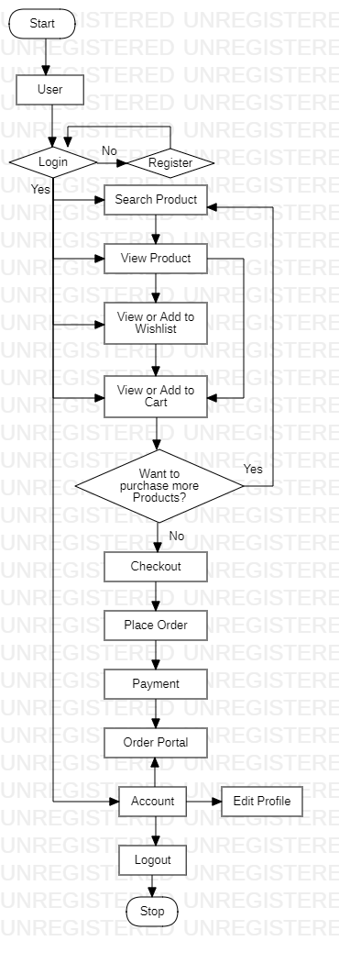

**B2: Use case diagram**

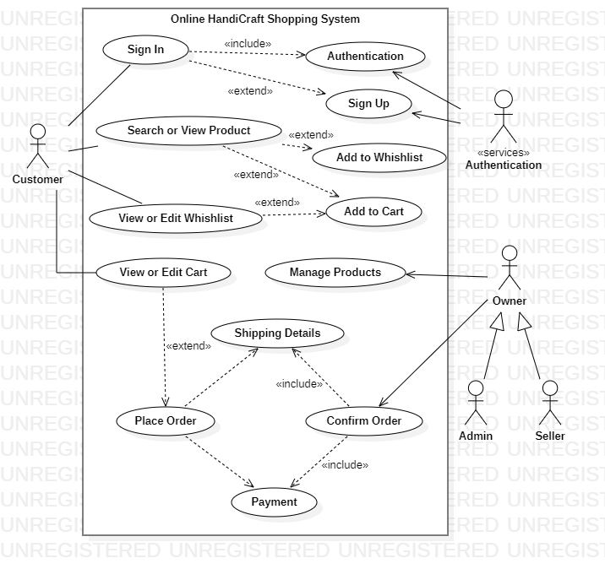

**B3: Activity diagram**

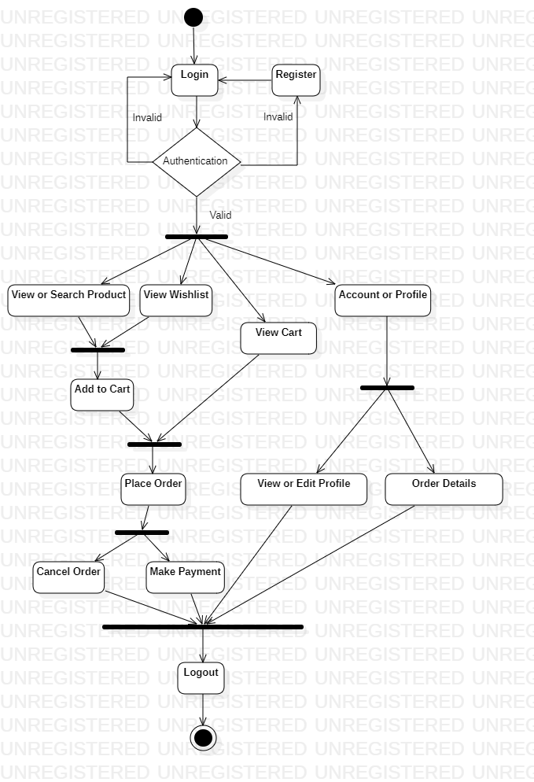

**B4: Class diagram**

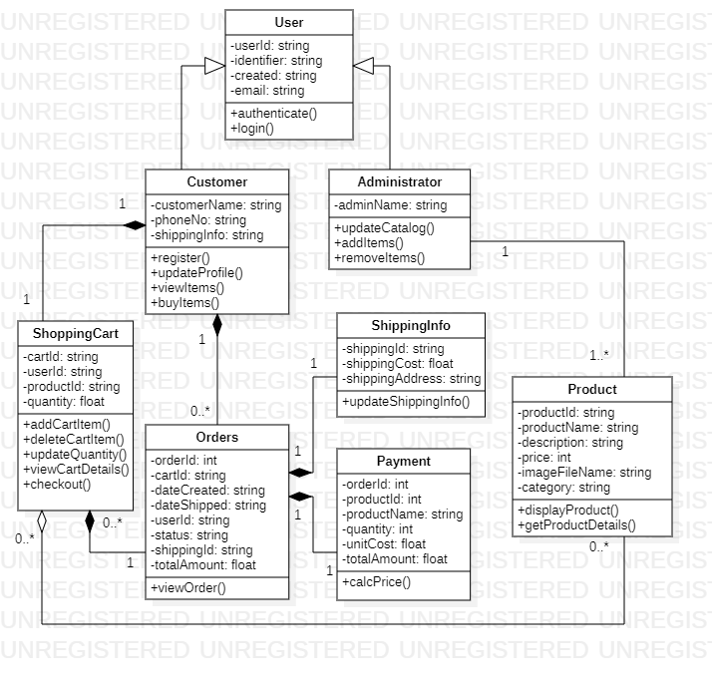

**B5: Sequence diagram**

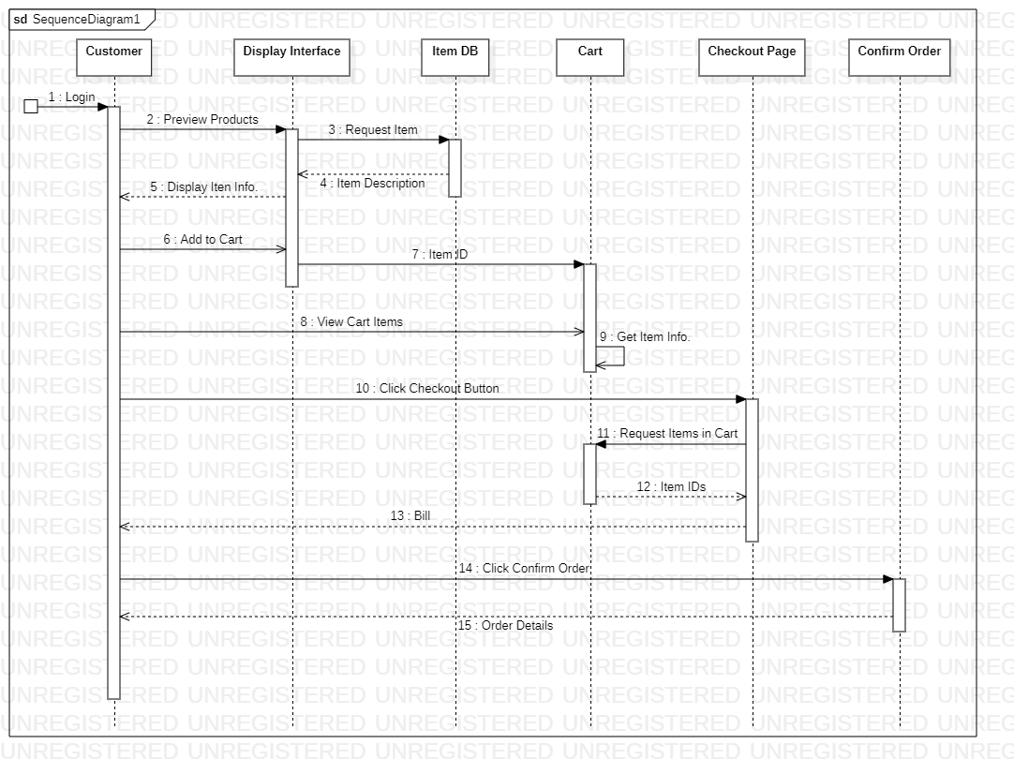

**B6: Data flow diagram**

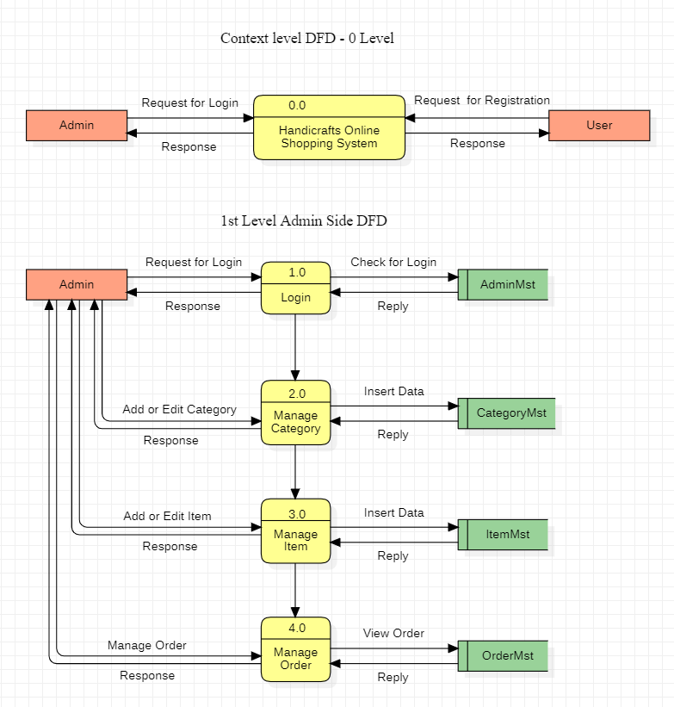

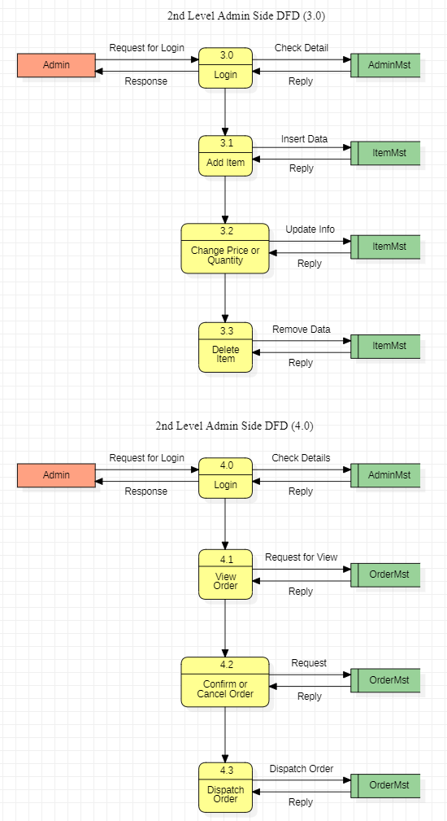** 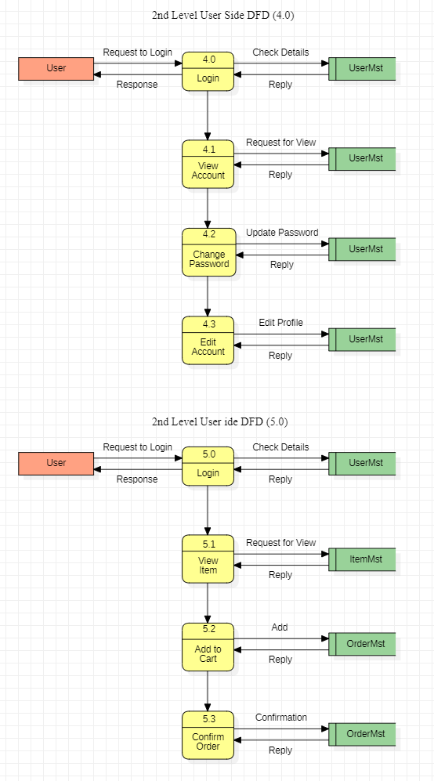

**Appendix C: Future Enhancements**

* Multiple payment methods as we have cash on delivery for now.
* No functionality related to notification is added at present and will be added soon.
* Android application for admin/seller.

**Splash Screen**



Displayed for shorter period on opening application.

**Welcome**

Welcome screen will be displayed when new user will open the app.

**Get Started** button will take the user to **Sign-In** screen.

**Sign In**

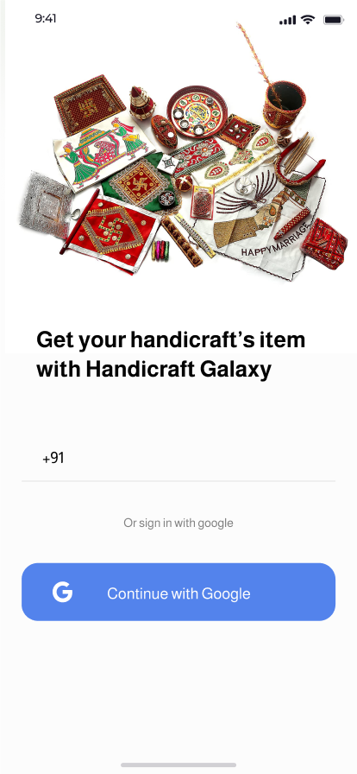

User has two option to sign into our app- either **Mobile Number** or **with** **Google**.

Selecting **Mobile Number** will go for OTP verification and

**With Google** will link your google account to sign-in.

**Number**

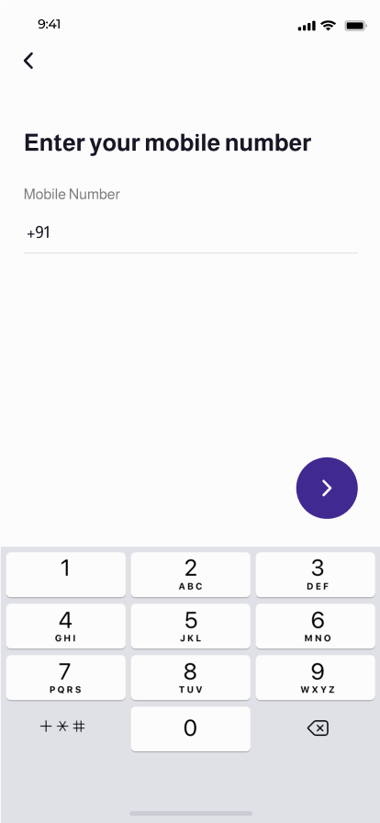

On previous screen, if the user clicks on textbox to enter mobile number, will be redirected here.

After entering number and hitting **next** button, the user will receive OTP on entered number and redirected to next screen.

**Verification**

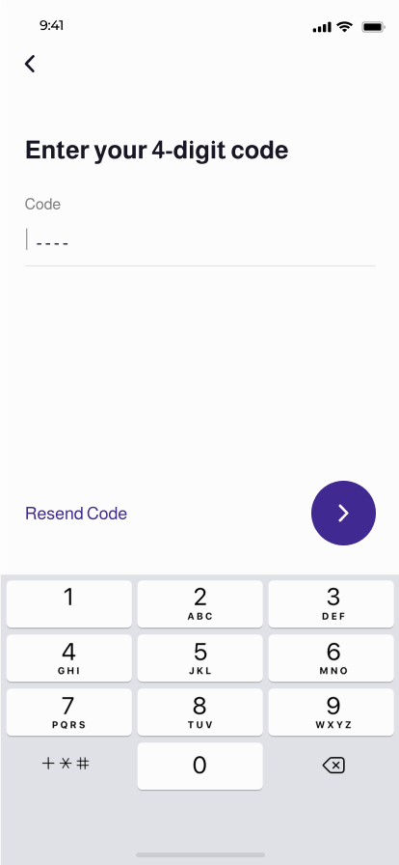

User must enter correct OTP here received from previous process and hit the **next** button to proceed to sign-in to our app.

**Home/Shop Screen**

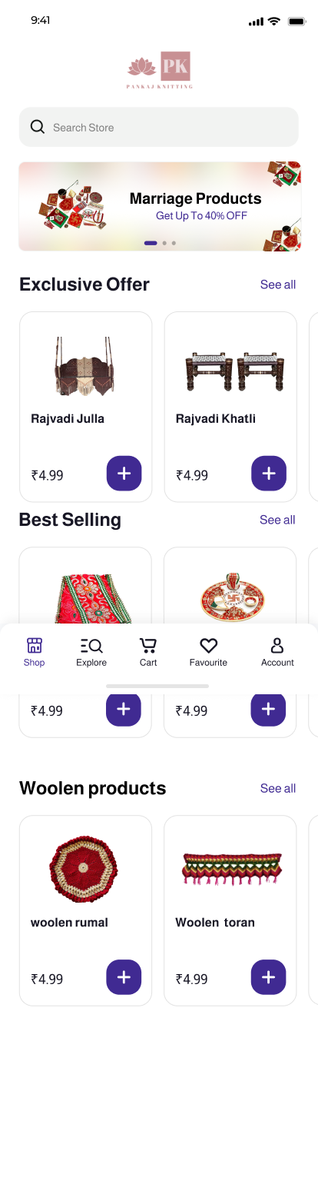

This screen will be displayed after successful sign-in to app.

It contains search bar in which user can search products from store.

And few category groups like **best-selling products, various offers, etc.**

**Explore**

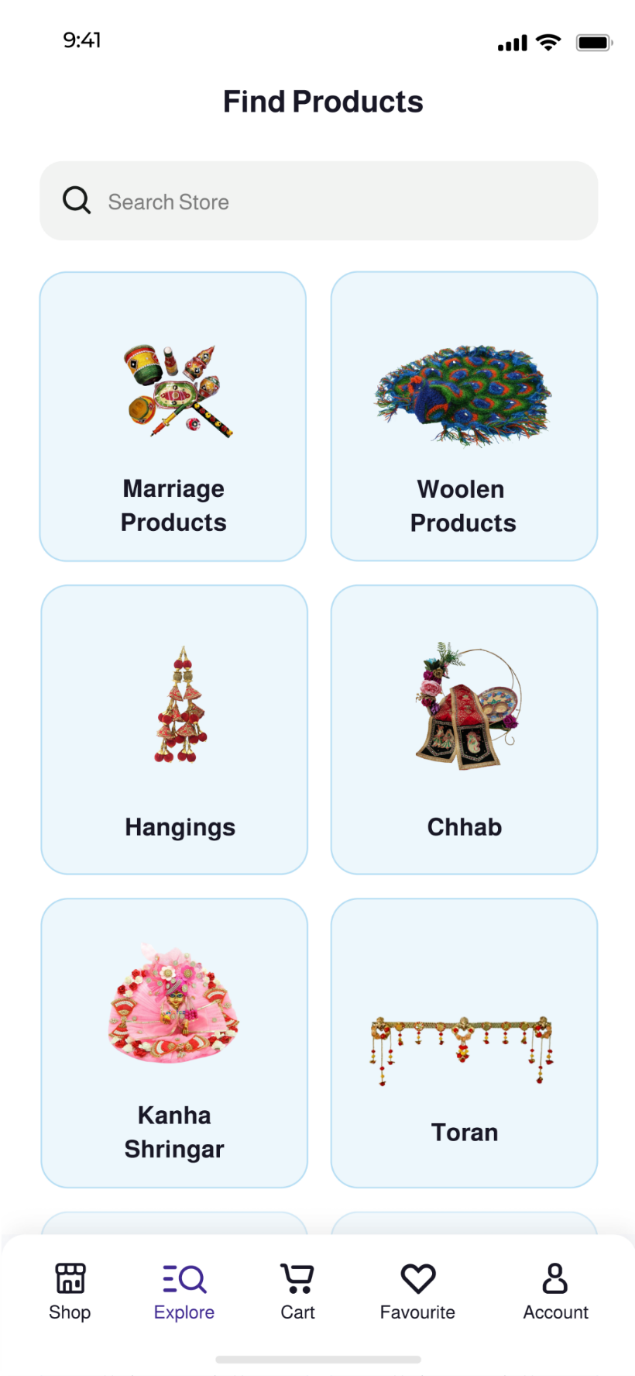

This screen be reached by clicking **Explore** tab in bottom bar. Different categories of products will be listed here in different clickable card views.

Also, a search bar is provided to search products in this.

**Catalog**

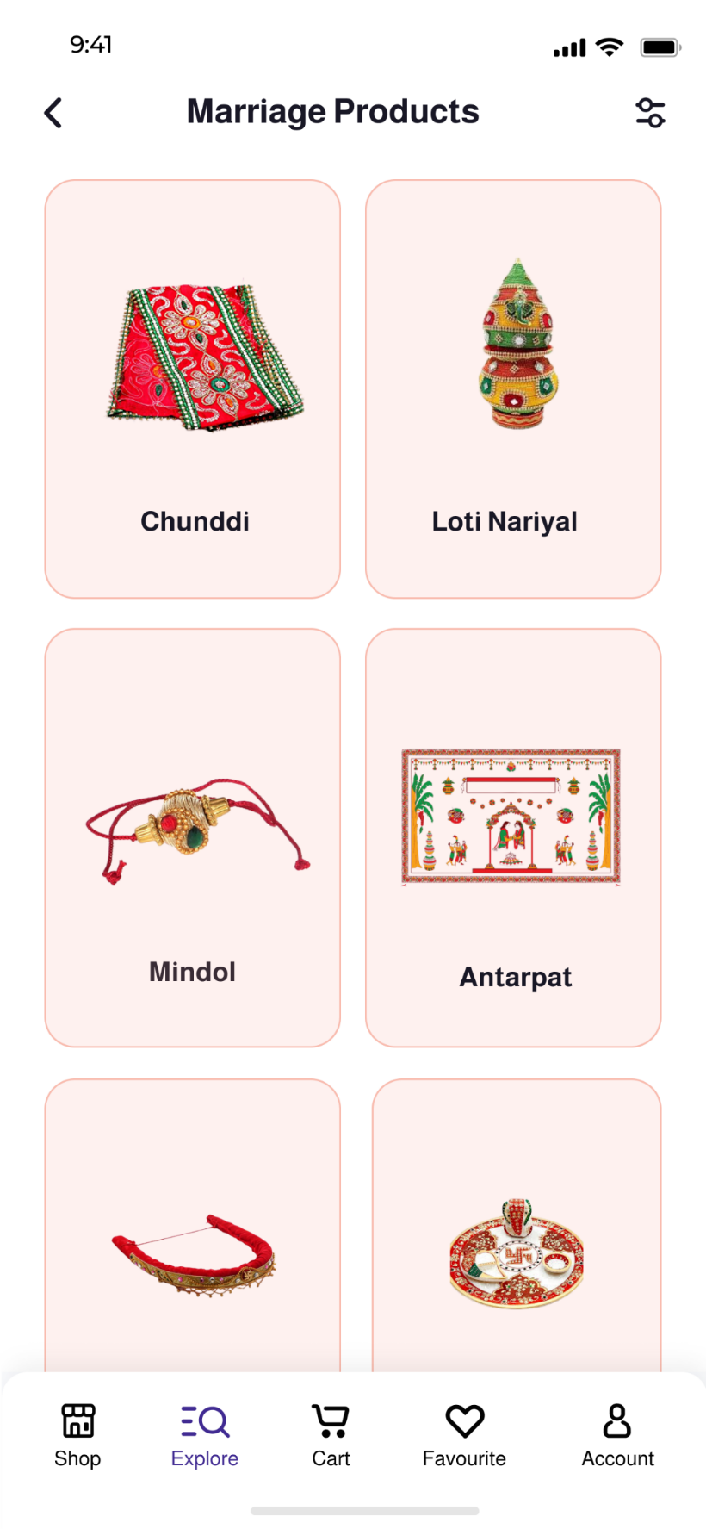

This screen is optional, and it will be displayed only if the user clicks the category which has a sub-category. It is very similar to previous screen.

**Search**

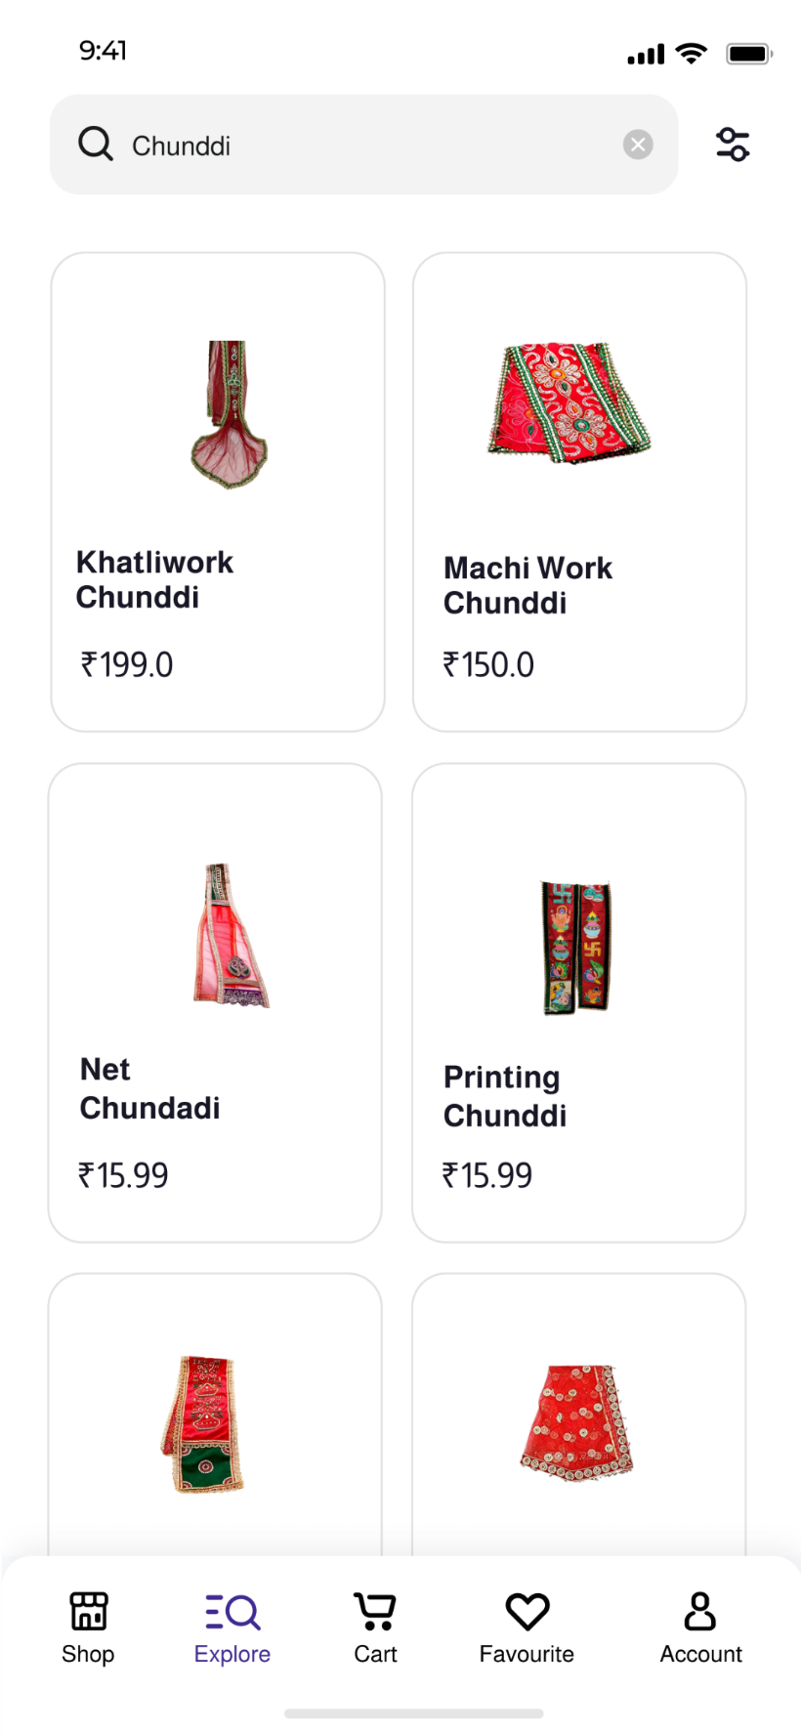

This screen will list the products of category selected by user from previous screen. It has search bar to search among products.

It has filter button on top right to apply filter and sort the products.

**Filters**

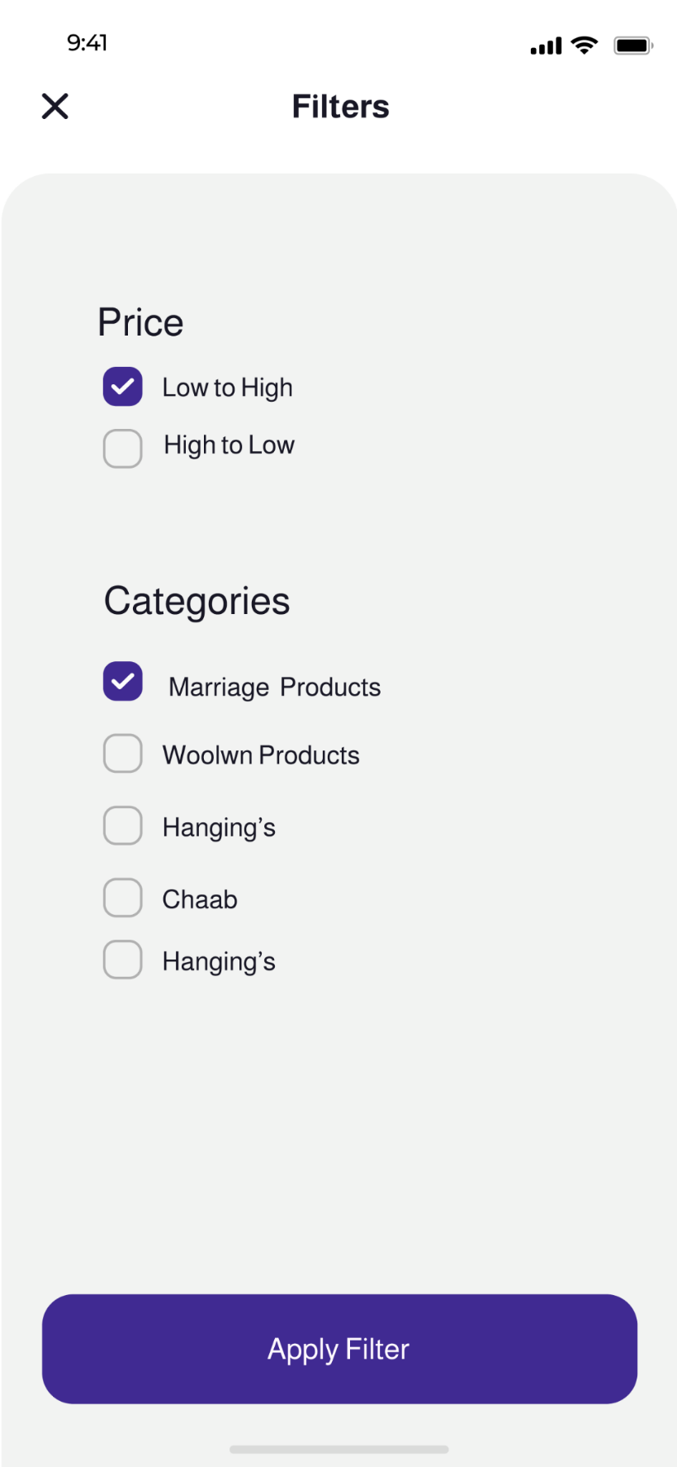

This is filter menu which will pop up when user click filter button on previous screen. It has option to select category of product and to sort the products according to price.

**Apply Filter** button will reload the screen with the product according to user selected options.

**Product Details**

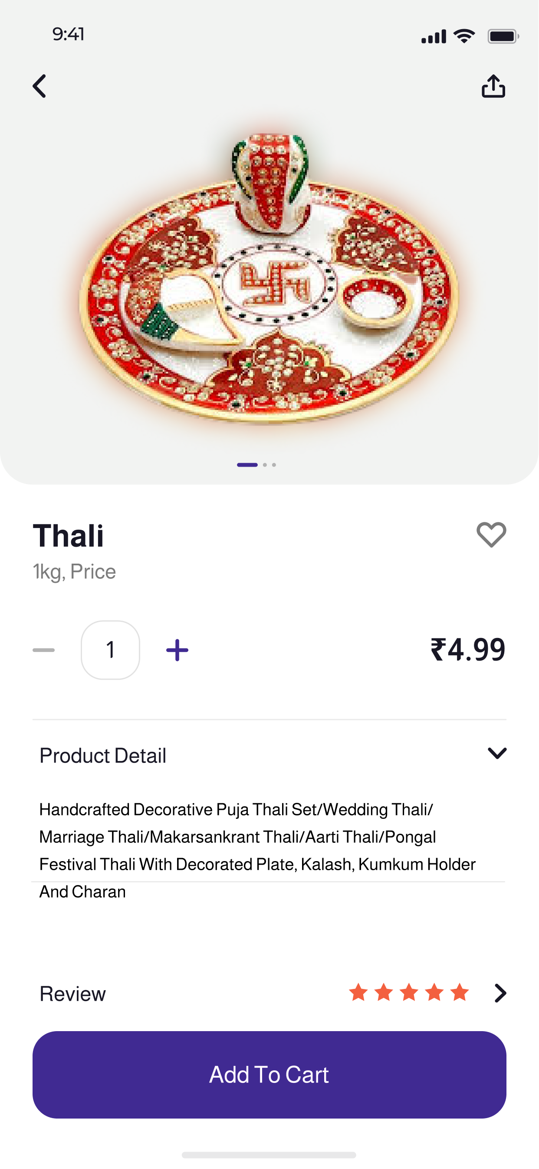

This screen shows the description and details of product after clicking the product from previously listed items.

**Favourite** button will add the product to favourite list.

**Add to Cart** button will add the item to cart.

**Cart View**

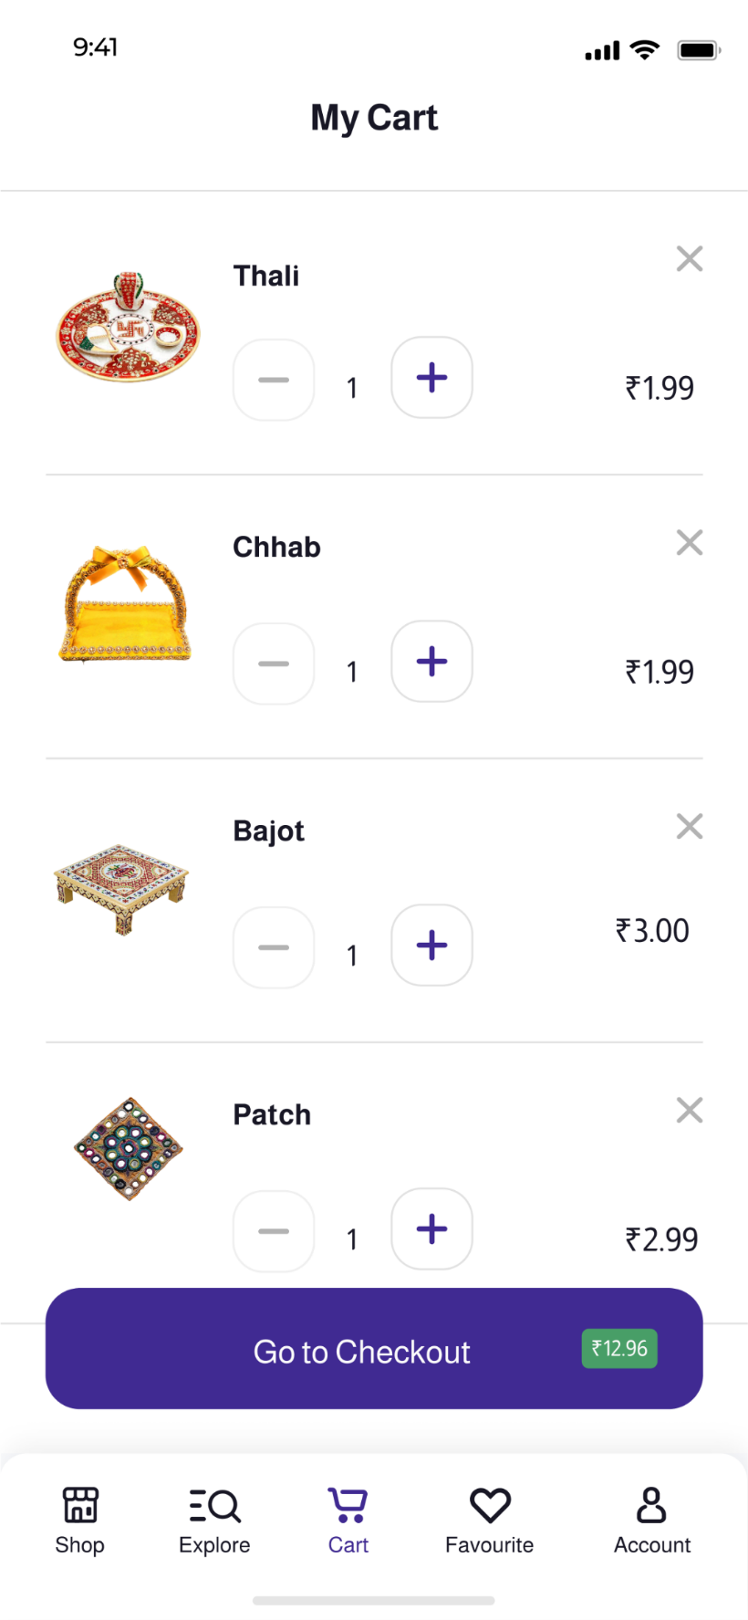

Click on **Cart** button in bottom bar will list all items in cart.

Clicking on each item will open description and details of item.

Two buttons are provided to add or remove number of items.

Onclick listener will take user to checkout and place the order for item in cart by clicking **Go to Checkout** button.

**Favourite List**

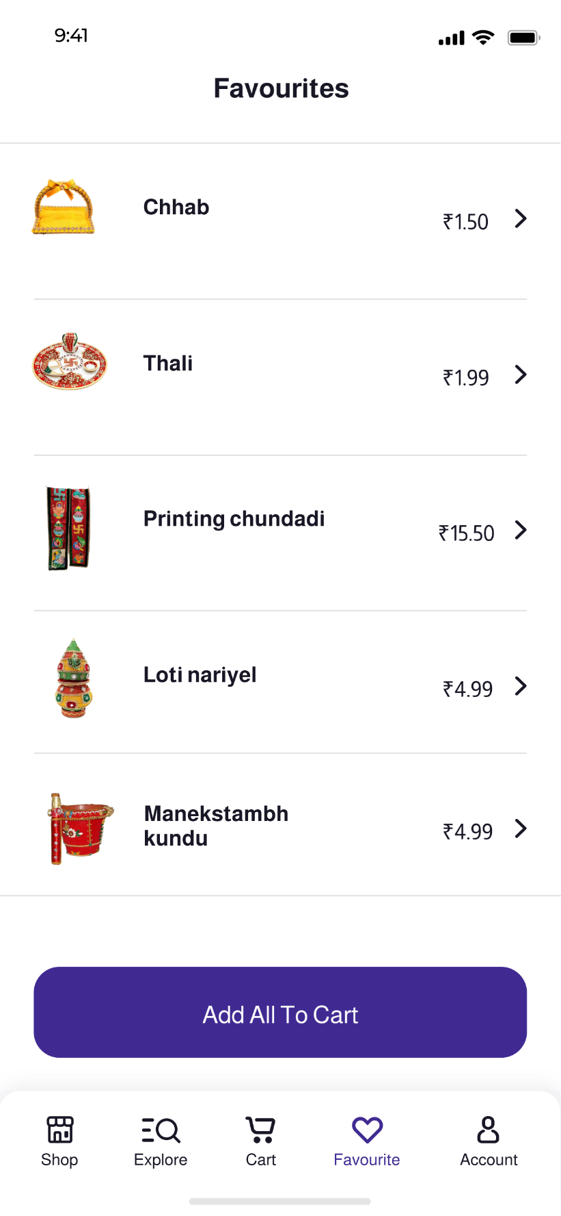

Click on **Favourite** button in bottom bar will list all items in favourite list.

Clicking on each item will open description and details of item.

User can add all items from favourite list to cart by clicking **Add All To Cart** button below.

**Checkout**

After clicking **Checkout** button in cart screen, user will be able to place order and this screen will be displayed.

It will allow user to select shipping address from the addresses saved in their profile and select payment method for payment.

**Place Order** button will confirm the order and check for valid user inputs.

**Success**

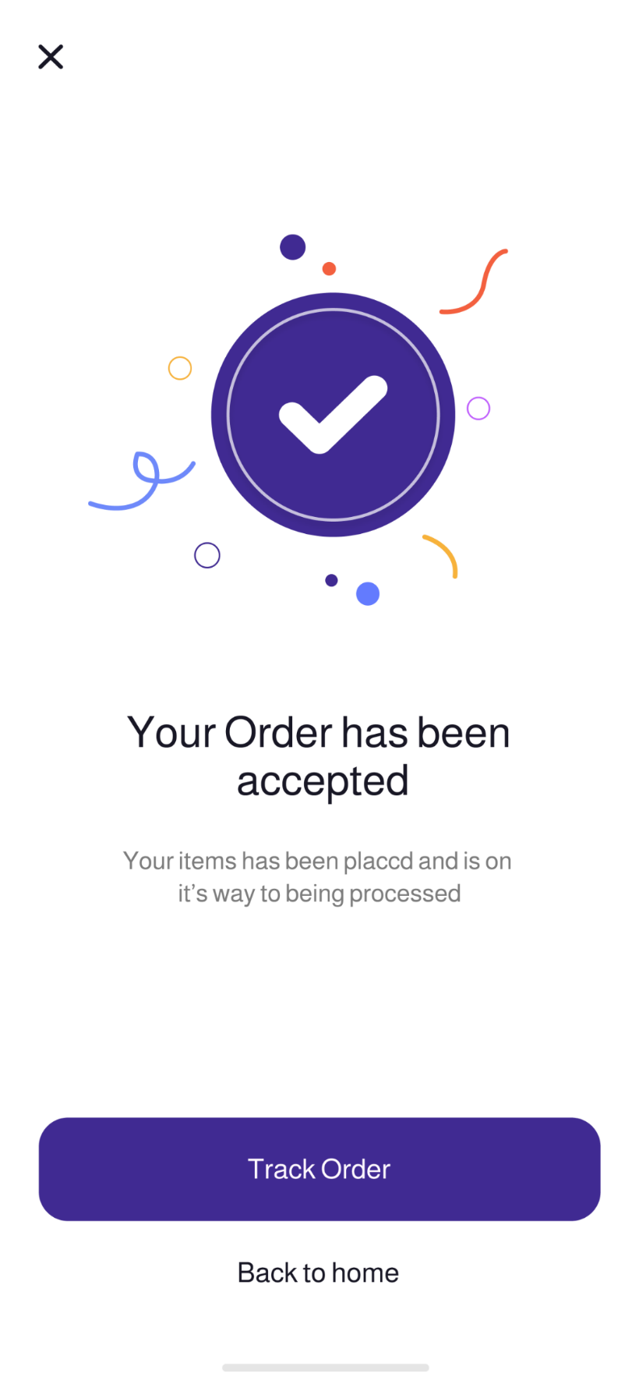

This screen will be displayed when the user clicks **Place Order** button and the order is confirmed.

It contains two buttons **Track Order** - it will redirect the user to orders screen.

and **Back to home** – it will take the user to home screen.

**Error**

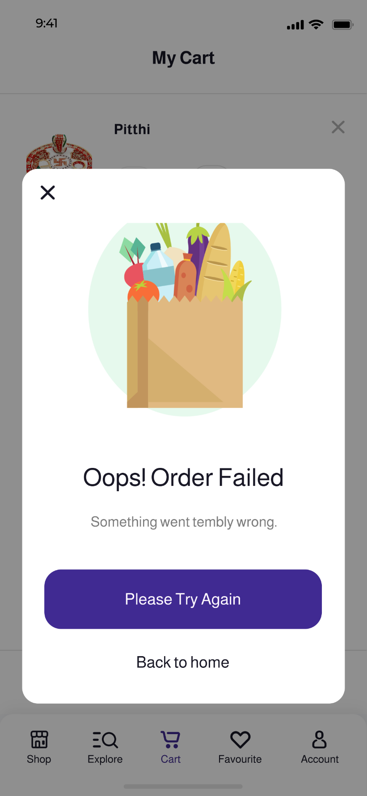

This screen will be displayed if any exception or error occurs during confirmation of order.

It contains two buttons **Please Try Again** - it will call the checkout method again and try to confirm order.

and **Back to home** – it will take the user to home screen.

**Account**

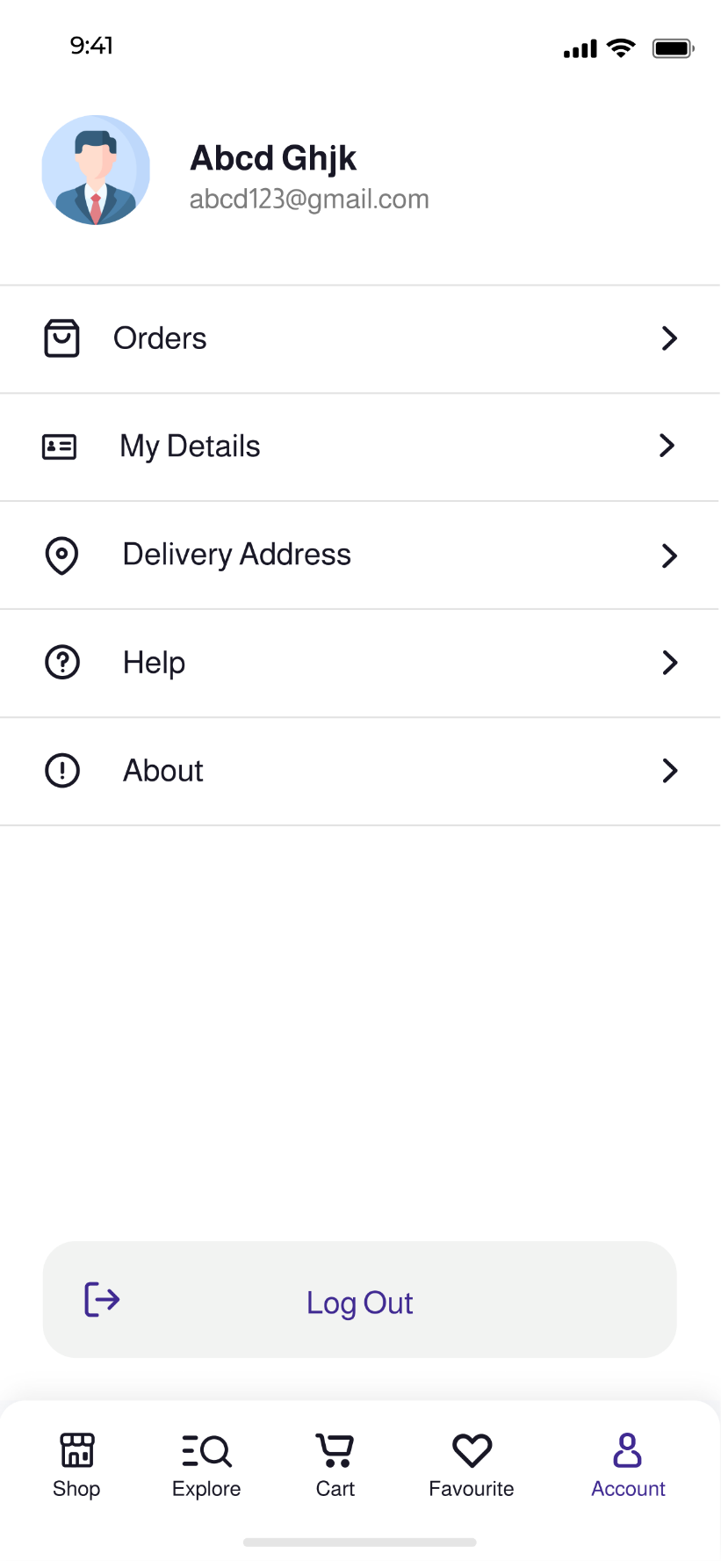

In Account screen, you can find buttons to view your **orders**, **details**, **delivery address**, **help** and **about**.

Clicking **Logout Button** will sign you out and end your session in session manager.

**Profile**

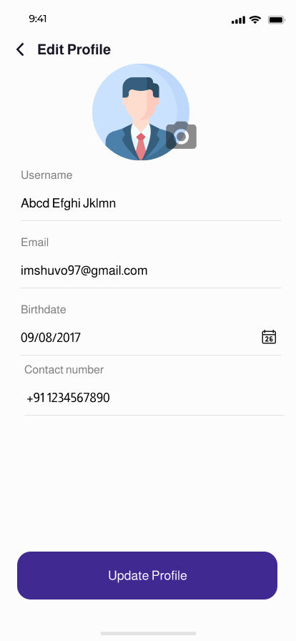

On clicking **My Details** button on account screen, user will be redirected to this screen from where he/she can update their information.

**Address**

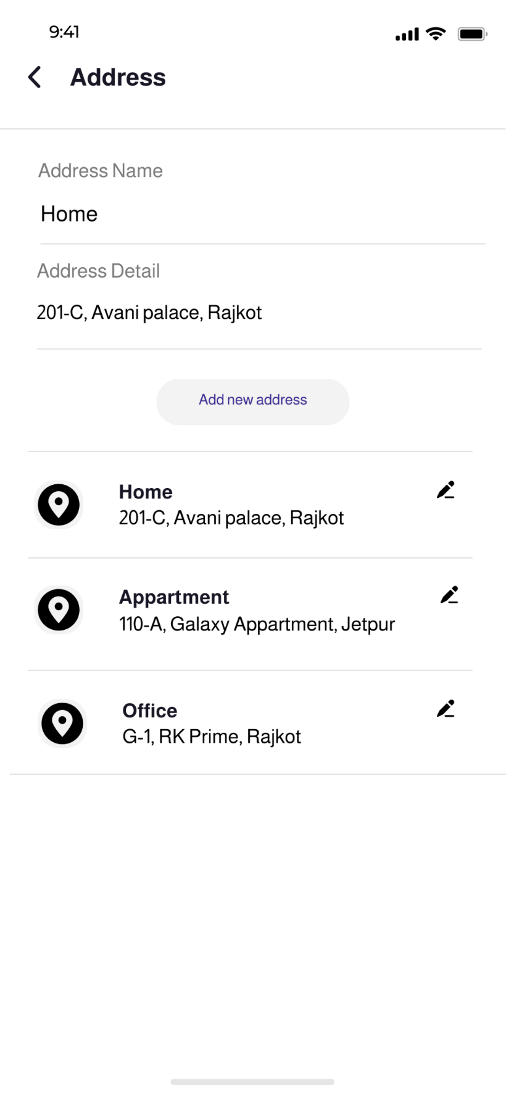

On clicking **Address** button on account screen, user will be redirected to this screen from where he/she can **add or update** shipping address which will be used for delivering their orders.

**Help**

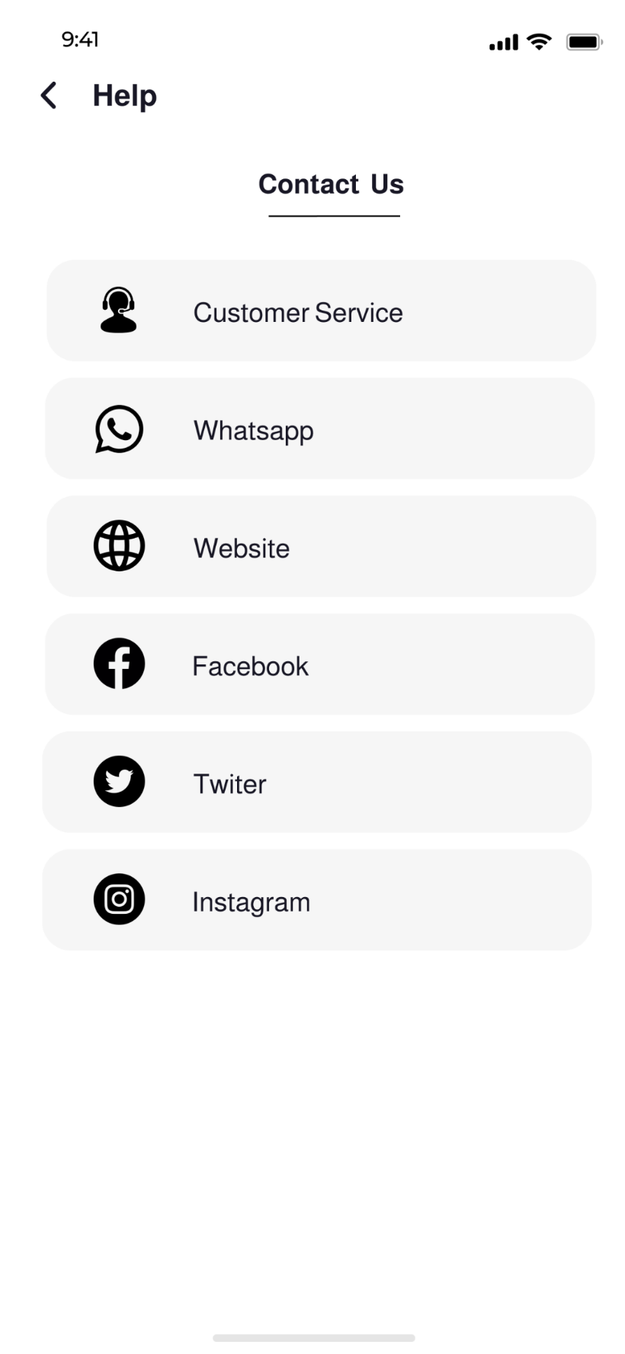

This screen will help the users to contact the admin (us) in case if they have any query or problem while using app which can solved manually.

**Orders (Ongoing)**

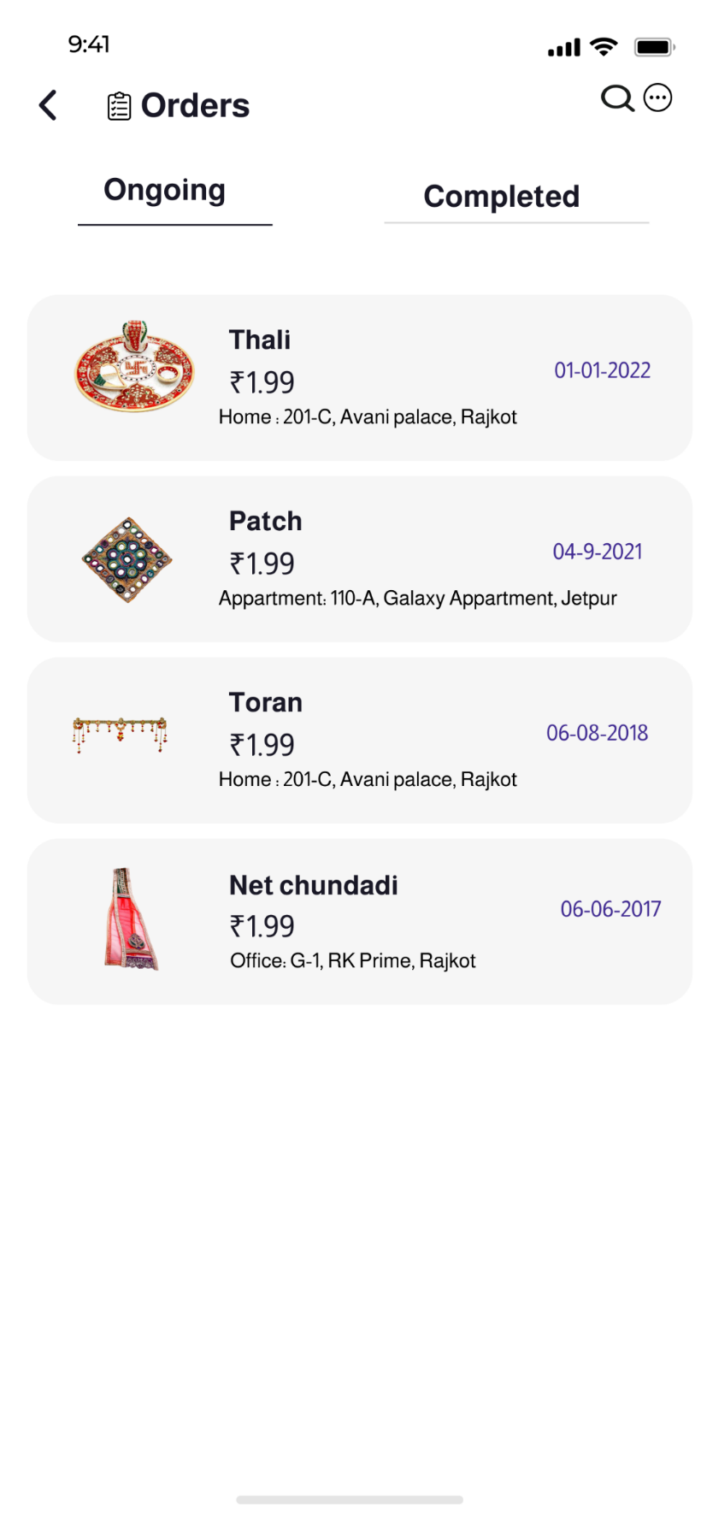

Orders - Ongoing will display orders which are yet to be delivered.

**Orders (Completed)**

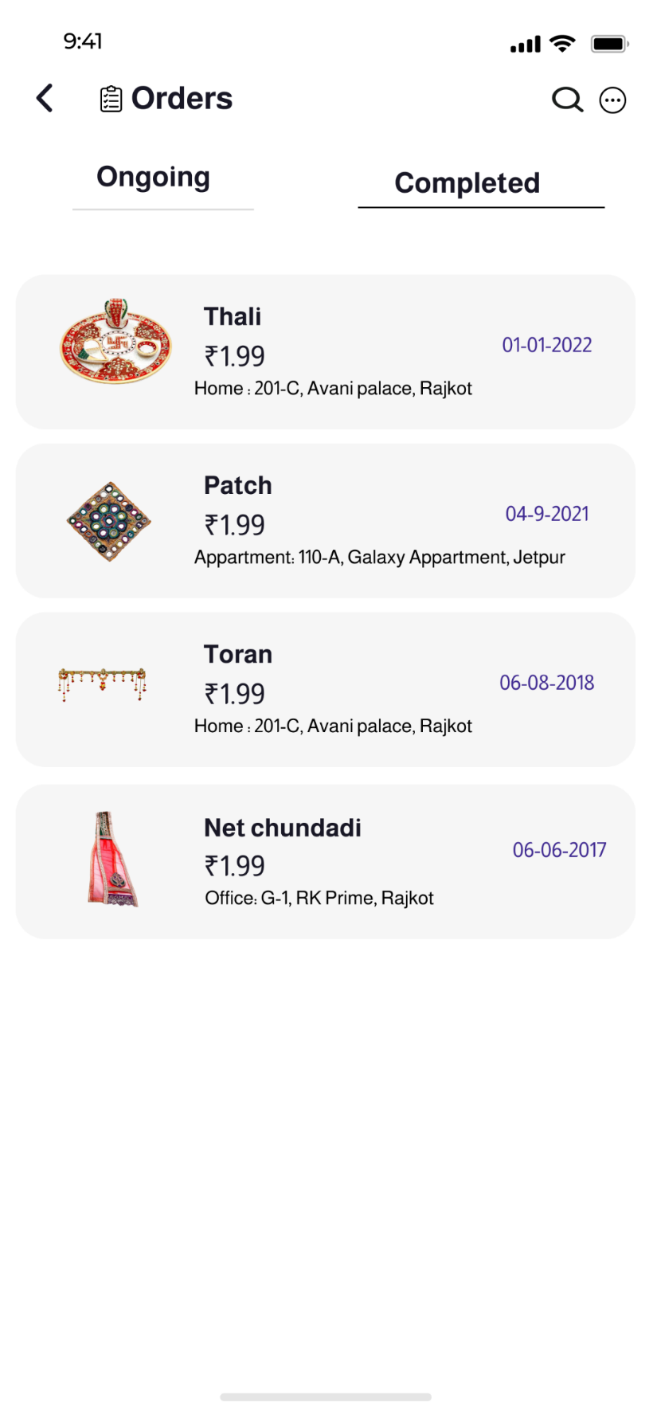

Completed will show all the previous orders that had been successfully delivered.